Verify Check  Cab  Cleanliness  Seat  Operator restraint  Instruments & labeling  Levers / Controls  Pedals  ROPS to AS 2294  Windows / wipers / washers  Rear view mirrors  Warning devices  Verify Check  Horn  Amber flashing beacon  Reversing alarm  Verify Check  Warning signs (in cabin)  SEAT BELTS MUST BE WORN  Verify Check  DANGER – BEWARE OVERHEAD WIRES  & UNDERGROUND SERVICES | Supplier verification & Plant details
 | Plant owner:
 | Address:
 | City/Suburb:
Verify Check  SWL  Crane chart | Phone:
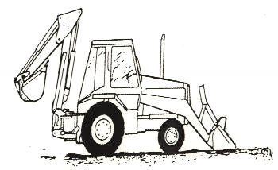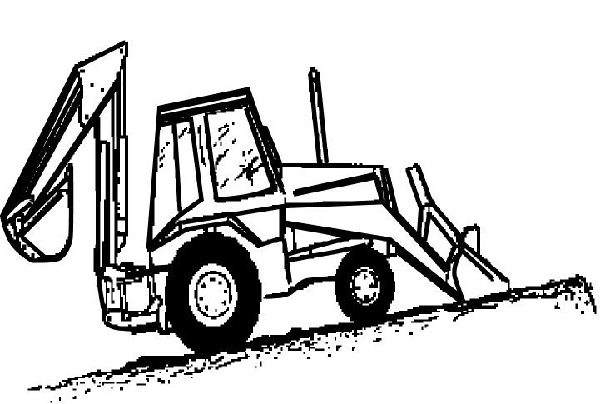 | Plant make:
Verify Check  Exhaust | Plant model:
Verify Check  Pivots  Connecting rods  Safety pins  (no excessive wear) | Serial no.:
Verify Check  Engine guarding | Signature:
Verify Check  SWL | Date:
Verify Check  Quick hitch  Safety pins  (where applicable) | Statement of operator competence required
Hydraulics  Verify Check  Rams  Hoses  Connections  (check for excessive  wear, leaks and creep)  Verify Check  Travelling hitch  Verify Check  Connecting rods  & safety pins  SWL |  Plant to conform to manufacturer’s specifications and Plant  Regulations.   Plant operator is to provide daily checksheets to MACDOW on a  weekly basis.   Where applicable, Personal Protective Equipment must be worn.   Plant Log Book detailing service history in accordance with Manufacturer’s specifications should be written legibly in English.   Contractor must produce proof of competence of operator, e.g.,  Certificate of Competence, Licence, detailed Log Book
Verify Check  (Signs on both sides of vehicle)  KEEP CLEAR  Verify Check  Handrails  Steps | Note: Sign only when all items have been checked
 | Plant check by:
Verify Check  Stabilisers  Instructions:  Verify Box to be ticked by Owner / Supplier / Operator prior to arrival onsite.  Check Box to be ticked after visual inspection by MACDOW | Position:
 | Date: |  | / /

